Multilingual UI with Dynamic RTL/LTR Layout Adaptation with ReactJS + Material UI

Abstract:
This document explains how to implement multilingual support in a web application while handling layout changes between Left-to-Right (LTR) and Right-to-Left (RTL) languages. Using a real-world dashboard developed during my internship as a case study, we demonstrate how to switch seamlessly between English and Arabic, adapt the user interface layout, and maintain a consistent user experience across both language directions.

Table of Contents
Abstract: 1
1.0 NPM Packages to Install 3
i18next 3
react-i18next 3
i18next-browser-languagedetector 3
@emotion/react 4
@emotion/styled 4
stylis 4
stylis-plugin-rtl 4
2.0 i18n.js File (Internationalization Configuration) 5
2.1 File Breakdown: 5
Importing required libraries 5
Translation Resources (Languages & Text) 6
Initializing i18next 7
3.0 ThemeRegistry.jsx (RTL / LTR Theme Manager) 9

1.0 NPM Packages to Install
Firstly, we need to install some NPM packages that will help us with the language detection and help us with the RTL support.
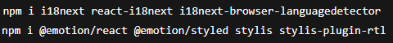

i18next
Purpose: Core internationalization (i18n) engine
What it does:
- Manages all translations in the app
- Stores language resources (English, Arabic, etc.)
- Handles language switching logic
- Provides translation keys Translated Text
Why we need it: It is the main library that makes multilingual support possible. Without i18next, the app would not be able to translate text dynamically.

react-i18next
Purpose: React integration layer for i18next
What it does:
- Connects i18next to react components
- Provides hooks like useTranslation(), which automatically re-renders components when language changes
Why we need it: i18next alone is not react aware. This package allows react components to update instantly when the language changes.

i18next-browser-languagedetector
Purpose: Automatically detects user’s preferred language
What it does:
- Detects language from:
  - local Storage
  - Browser language
  - System settings
- Saves selected language
- Restores language on refresh
Why we need it: So, the user does not need to reselect language every time they reload the page. This gives professional user experience.

@emotion/react
Purpose: Emotion is the styling engine used by Material UI (MUI)
What it does:
- Applies styles dynamically in JavaScript
- Allows us to switch styles at runtime
- Required for theme direction switching (LTR / RTL)
Why we need it: MUI is built on Emotion, without it we cannot control direction aware styling

@emotion/styled
Purpose: Styled-components syntax for Emotion
What it does:
- Allows custom styled components
- Used internally by MUI
- Helps maintain consistent styling system
Why we need it: MUI depends on it internally, especially when themes change direction.

stylis
Purpose: CSS preprocessor used by Emotion
What it does:
- Parses CSS
- Transforms styles before they are applied to the browser
Why we need it: RTL transformation happens at this level.

stylis-plugin-rtl
Purpose: Automatically converts CSS from LTR RTL
What it does:
- Converts:
  - margin-left margin-right
  - padding-left padding-right
  - left right
Why we need it: This is what makes the entire dashboard / UI flip correctly when Arabic is selected. Without this plugin, RTL support would require rewriting all CSS manually.

2.0 i18n.js File (Internationalization Configuration)
The i18n.js file is the core configuration file responsible for enabling multilingual support (English & Arabic) in the React application.
It defines:
- Available languages
- Translation text
- Language detection
- Language persistence
- How translation is accessed in components
Purpose of the i18n.js file:
This file initializes the i18next engine and connects it to react so that:
- Text can be translated dynamically
- Language can be changed at runtime
- The selected language is remembered after refresh
- Components re-render automatically when language changes

2.1 File Breakdown:

Importing required libraries
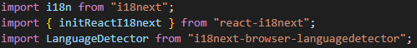
First, we import the required libraries. What each import does:
- i18next: Core translation engine
- initReactI18next: Connects i18next to React so components can re-render when language changes
- LanguageDetector: automatically detects the user’s preferred Language

Translation Resources (Languages & Text)
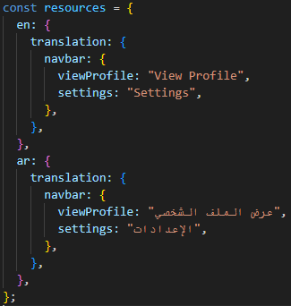
In this example, we will use the navbar elements to translate its text.
What this means:
- Each top-level key is a language code:
  - en English
  - ar Arabic
- Inside each language, we define translation object
- Translation keys are grouped logically:
  - Navbar
  - Sidebar
  - Common
  - Etc.
Why we use keys instead of hardcoded text:
- Easier to maintain
- Easy to add new languages
- No duplicate components
- Clean professional structure
Example usage in components:
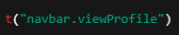

Initializing i18next
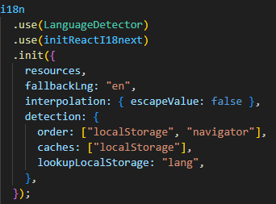
What Happens here:
- use(LanguageDetector) Enables automatic language detection
- use(initReactI18next) Enables React Integration
- init({…}) Starts the i18n engine with our configuration
What happens inside init ({…}):
The init() method is where we configure and start the i18n engine. It tells i18next what languages exist, how to choose a language, and how to behave if something is missing.
- resources:
  - Defines all available translation in the application
  - Each language has its own translation object
  - Translation keys are mapped to real text
  - i18next uses this as the source of truth
  - For example:
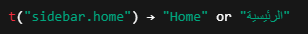
  - Without resources, i18next would have no translation to display
- fallbackLng:
  - Sets a default language when
    - Translation key is missing
    - Language detection fails
    - Unsupported language is detected
  - This prevents the app from breaking or showing empty text
- interpolation:
  - Controls how dynamic values inside translation are handled
  - False is correct in react because react already escapes values, prevents double escaping, and keeps text clean

- detection:
  - This block defines how the language is detected and remembered
    - order: i18next will check languages in this order
      - localStorage previously selected language
      - navigator browser/system language
    - caches: saves selected language to browser storage and persists language across refreshes
    - lookupLocalStorage: Defines the key name used in localStorage

3.0 ThemeRegistry.jsx (RTL / LTR Theme Manager)
The ThemeRegistry.jsx is responsible for flipping the entire UI between Left-To-Right (LTR) and Right-To-Left (RTL) when the language changes. It connects language (i18n), layout direction, MUI theme, and emotion styling engine into one unified system.
This file ensures:
- English LTR layout
- Arabic RTL layout
- MUI components flip automatically
- CSS styles flip automatically
- The <html> direction updates correctly
Without this file:
- Arabic text will display, but the layout stays LTR
- Sidebar, menus, spacing, will all be wrong

3.1 File Breakdown

Importing required libraries
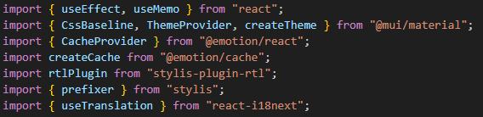
What these imports do:
- ThemeProvider / createTheme Allows us to control MUI theme direction (LTR / RTL)
- CacheProvider Let’s us use different Emotion caches (LTR vs RTL)
- stylis-plugin-rtl Automatically flips CSS rules
- useTranslation Gives access to current language

Emotion caches (LTR & RTL)
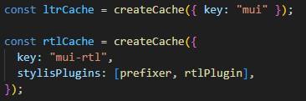
Why we need 2 caches:
Emotion processes styles before they reach the browser.
- ltrCache: Normal CSS
- rtlCache:
  - CSS transformed automatically:
    - margin-left margin-right
    - padding-left padding-right
    - left right

Detecting direction from language
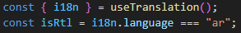
What happens here:
- We read the current language from i18n
- If language is Arabic RTL
- If language is English LTR
This is the bridge between language system layout system.

Updating <html> tag direction
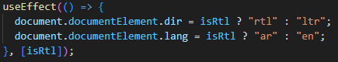
Why this is critical:
- Browsers rely on dir attribute for layout
- Screen readers need correct lang
- Native scrolling direction changes
- Flexbox and grid respect direction automatically

Creating the MUI theme
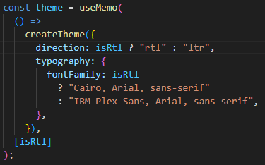
What this does:
- Tells MUI which direction to use
- Automatically flips:
  - Menus
  - Drawers
  - Icons
  - Alignment
  - Spacing
useMemo is used to avoid recreating theme on every render (performance).
Applying the provider
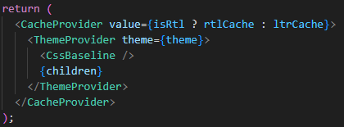
What happens here:
- Order matters:
  - CacheProvider: Decides how CSS is transformed (RTL or LTR)
  - ThemeProvider: Applies MUI rules
  - CssBaseline: Resets styles for consistency
  - children: The entire app

